**CS590BD Big Data Analytics and Apps**

**Second Increment Report – Group2**

**Tetris**

**A Sensor based Motion Game**

**Kommineni, Siva Krishna**

**Ponnam, Balakrishna**

**Boyanapalli, Swathi**

**Pathuri, Savya Sri**

**Summary:**

For the second iteration the main focus is made on the selection of the open source applications and looking for establishing a connection between the game movements and the sensor tag movement directions. We used certain tools for analyzing the connection establishment and finding out the right algorithm for data classification and analysis. Our back end work majorly consists of analyzing the data and cluster the list of motions based on certain actions and movement in the space. Some amount of work has also been spent on the developing of UI part and investigations were made for developing an open source application according to our specifications and direction movement for the detection of various motions.

**Framework Specifications:**

In this increment we made progress in the selection of the game and analyzing the direction movements present in it so that we can match it with the sensor tag direction movement. First we should collect the data, push it into HBase and host a restful web service using the Glassfish server. We are trying for the connection establishment between the accelerometer data in the application file and the sensor tag accelerometer connections. Currently we are running the application on the emulator for searching the exact movements. The mobile client is entirely developed in Android and it is a native application for android users. The version supports from Froyo to Jellybean’s.

**Application Specification:**

* **Software Specification**
  + Tools: K-Means, R, HMM, Android Development Kit, Eclipse Kepler
  + Operating System: Android
  + Development Operating System: Windows 8
  + Programming Language: Java 7.0
  + Databases: HBase, Hadoop

**Activity Recognition Scenario and Data Collection**

* **Devices/Sensors:**

## Sensors: TI Sensor Tag - CC2541DK-SENSOR

**Devices: Android devices**

* Bluetooth 4.0 compatible android device
* Android 4.3 or above OS
* GPS

**TI chronos Watch – EZ430-Chronos**

**Implementation:**

The implementation part typically consisted of three parts. They are:

* Establishing the connection between the sensor tag movement and the open source game actions.
* Collection of the Data and pushing it on to HBase and creating a restful web service by deploying it on the glassfish server.
* Analyzing the collected data based on the actions and sensor movement and classifies the actions based on the classification and clustering algorithms.

First we implement the application using an open source android game called Tetris.

We installed it on our local Eclipse ADT and the package structure is formed as shown below in the frame work.

**On-line motion based game app using Data Processing and Motion Recognitions apps:**

For developing the game with sensors we have downloaded android open source game from the github. The game we downloaded is **Tetris** which is known to everyone who played videogame in the childhood.

The following is the github link from which we have downloaded the code:

<https://github.com/semenoh/Tetris>

**Overview of the Game:**

The game is Tetris where we get different objects which we can rotate all those objects and can move towards the left and towards right. On moving those it will be coming down if it made a row then the row will be collapsed and level goes on increasing once it touch the upper the game will be over.

**How the game implemented using sensor devices:**

The game is modified for developing the game to use with the sensor devices. For operating the game with sensor devices we have developed the app for collecting the data. The data we have collected is by using the Samsung app which collects the accelerometer, Humidity, and Temperature data. The data gesture we have collected for this application is **Left to Right**, **Right to Left** and **Rotation**.

It also has the sensor tag related services and applications present in it. We are investigating in the part of the service connections and establishment with the sensor tag.

To test the application we are running it on the emulator for performing the basic operations.

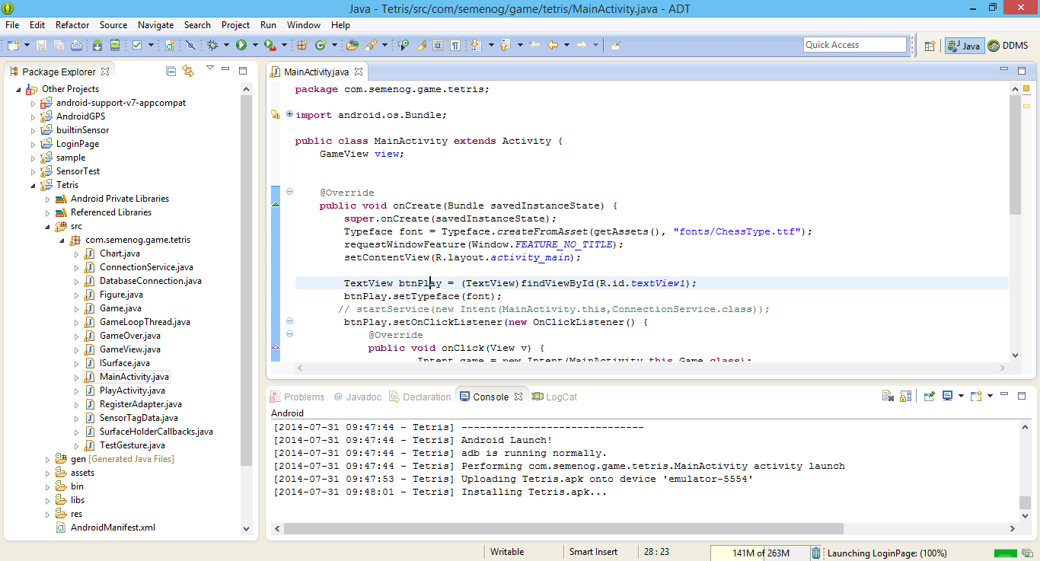

We run it as an Android application so that it will be launched on the emulator.

The screen below shows that the emulator is being launched successfully in the console.

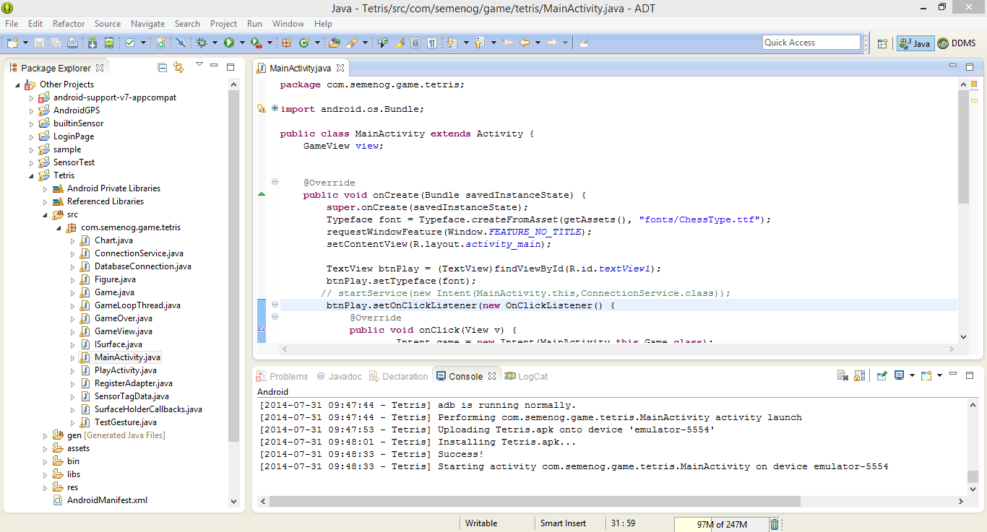

**Running Game:**

On running the game with sensor devices we get the Play button.

The below screen shot shows the beginning of the game with the play button:

The below figures shows the sequence of basic operations in the open source game. First it shows the app named Tetris in the UI. After launching it by clicking on the icon we get the page shown as below.

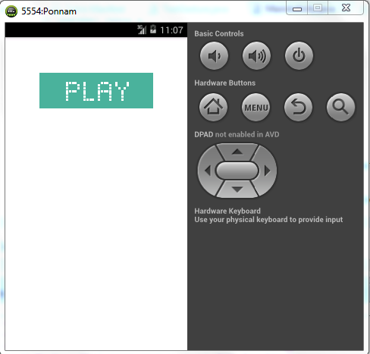

On pressing the play button the game will be running by generating the objects. Those objects can be moved towards Right and Left and can also rotate the object.

The object goes down untill it reaches top.We can move the object and make a row without any space so that the row will be deleted. If we got the row with some spaces then no row will be deleted and the objects get add on adding and touch the top where the game get over.

Here the code is modified to make the objects movable by using the sensor data where before the sensor data is trained and tested data with sequential files where the motion can be trained and perform the action.

The below screen shows the objects falling down and which can be moved left and right:

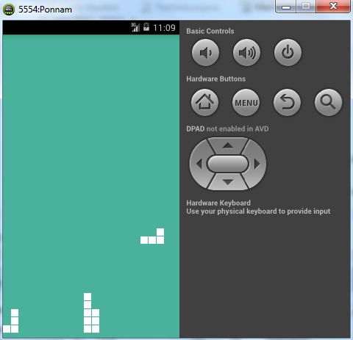

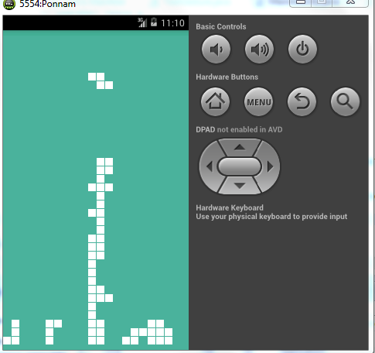

* We are using glassfish server to install as a restful web service and use the data collected in our applications. We can run the deployed applications as shown by launching them

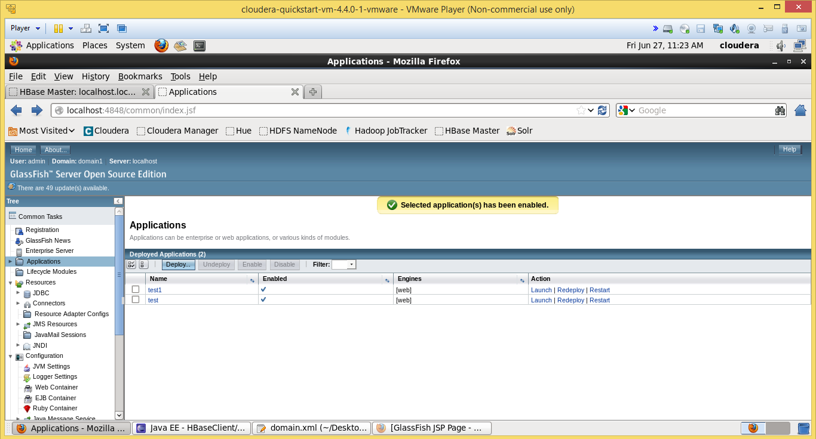

We are deploying some sample data and hosting a web service for it to run as a web server.

**Project Management:**

All the task planning according to the iterations are maintained in scrumdo and task allocation is shared equally among the team members.

<https://www.scrumdo.com/organization/umkc94/dashboard>

* **Third Increment:**

The tasks that will be included for third increment are:

1. Creation of Restful web services.
2. Execution of applications for analyzing movements.
3. Testing and training the collected data using existing services.
4. Analyzing collected open source game for development.
5. Investigation on the game and sensor connection establishment.

The above mentioned tasks will be uploaded the scrumdo tool with specified timelines.